# Promoted Display - Advertising Dashboard

# ****Advertising Dashboard - Content****

|  |  |  |  |  |
| --- | --- | --- | --- | --- |
| **Position** | **#** | **Mock Content** | **Final Content** | **Notes/Use Cases** |
| Entry Banner | 1 | **Try Promoted Display BETA** | **Try Promoted Display BETA** |  |
| Banner Messaging | 2 | Drive traffic to your store with new category-targeted Promoted Display ads.   Get started today! | Drive traffic to your store with new category-targeted Promoted Display ads. Get started today! | Note "Get started today!" - links to campaign creation flow |
| CTA to Banner | 3 | Try it now | Try it now | Links to creation flow |
| Metric's Toggle | 4 | Metric: Clicks | Metric: Clicks | Metrics reported will showcase Clicks, Impressions and Sales |
| Info Bubble | 5 | Impressions:  The number of times your Promoted Display ads appear on listings pages. | Impressions: The number of times your Promoted Display ads appear on listing pages. |  |
| Info Bubble | 6 | Clicks: ~~The number of visits to a listing page from a Promoted Display Ad.~~ | Clicks: The number of times buyers click your ads to land on a category page of your store. |  |
| Info Bubble | 7 | ~~Sold: The number of promoted items purchased within 30 days of a Click on your offsite ads~~ | Sold: The number of Buy It Now items in your store purchased within 30 days of a click on your Promoted Display ads. | Added "Buy It Now" |
| Info Bubble | 8 | Sales:  The amount of Sales generated by promoted items sold within 30 days of a Click on your offsite ads.  This figure shows all Sales via offsite ads, including returned or canceled transactions. | Sales: The total sales of Buy It Now items purchased in your store within 30 days of a click on your Promoted Display ads. The total sales amount includes your item price, shipping, taxes, and any other applicable fees.  This figure shows all Buy It Now sales via Promoted Display ads, including returned or canceled transactions. | Added "Buy It Now" |
| Info Bubble | 9 | CTR | CTR: Click-through rate. Clicks divided by Impressions. The CTR is the percentage of times buyers saw your ad and clicked on it.  Use this figure to measure how appealing your Promoted Display ads are to potential buyers. |  |
| Info Bubble | 10 | ~~Sales conversion rate: Sold divided by~~**~~C~~**~~licks. The sales conversion rate is the percentage of promoted items that are purchased after the buyer has clicked on them from your offsite ads campaign.~~ | ROAS: Return on ad spend. Sales divided by Ad Fees. The amount of Sales you generated per dollar spent on advertising. | This view is showing the metrics for Promoted Listings Advanced (Promoted Listings Advanced is selected in the drop down in image).  We should be showing the **Promoted Display view** instead, reporting **ROAS** instead (as sales conversion rate is not a metric for Promoted Display) |
| Info Bubble | 11 | Average CPC | Average CPC: Average cost per click. Ad fees divided by Clicks. The average amount you spent on advertising per click. |  |
| Info Bubble | 12 | Ad fees | Ad fees: The total amount of advertising fees incurred by clicks on your Promoted Display ads. Please refer to your Payments tab for final fees, including any applicable taxes or credits. | US |
| Info Bubble | 12 | Ad fees | Ad fees: The total amount of advertising fees incurred by clicks on your Promoted Display ads. Please refer to your Payments tab for final fees, including any applicable taxes or credits. (excl. VAT) | UK |
|  |  |  | Ad fees: The total amount of advertising fees incurred by clicks on your Promoted Display ads. Please refer to your Payments tab for final fees, including any applicable taxes or credits. (excl. GST) | AU |
| Info Bubble - Message | 13 | Metrics are reported in near-real time, allow approximately 72 hours to reconcile. All reporting data will be in your site timezone. Need content from legal team. | Metrics are reported in near-real time. Allow approximately 72 hours to reconcile. All reporting data will be in your site timezone.  Sold and Sales metrics consider all items in your store. Sales attributed to Promoted Display may overlap with sales attributed to other eBay ad products. |  |
| Legend Title | 14 | Promoted listing | Promoted Display clicks  Note: For other graphs, legend should read "Promoted Display impressions" and "Promoted Display sales" |  |
| Reporting Graph line | 15 | Blue line | Blue line | See Reporting Line Image.  Needs to connect to metric toggle so Seller can view metrics, sales and clicks. For Sales, include "Ad Fees" |
| Section Title | 16 | Promoted Listings Advanced | Promoted Display Campaigns |  |
| Info Bubble | 17 | Metrics are reported in near-real time, allow approximately 72 hours to reconcile. All reporting data will be in your site timezone. | The data shown below is for the past 90 days only. Use the Summary section above to view campaign data beyond 90 days. |  |
| Campaign type drop down | 18 | Promoted Display Advanced | Promoted Display | This view is showing the metrics for Promoted Listings Advanced (Promoted Listings Advanced is selected in the drop down in image).  We should be showing the **Promoted Display** view |

# ****Advertising Dashboard - Image**** Start of Promoted Display Journey

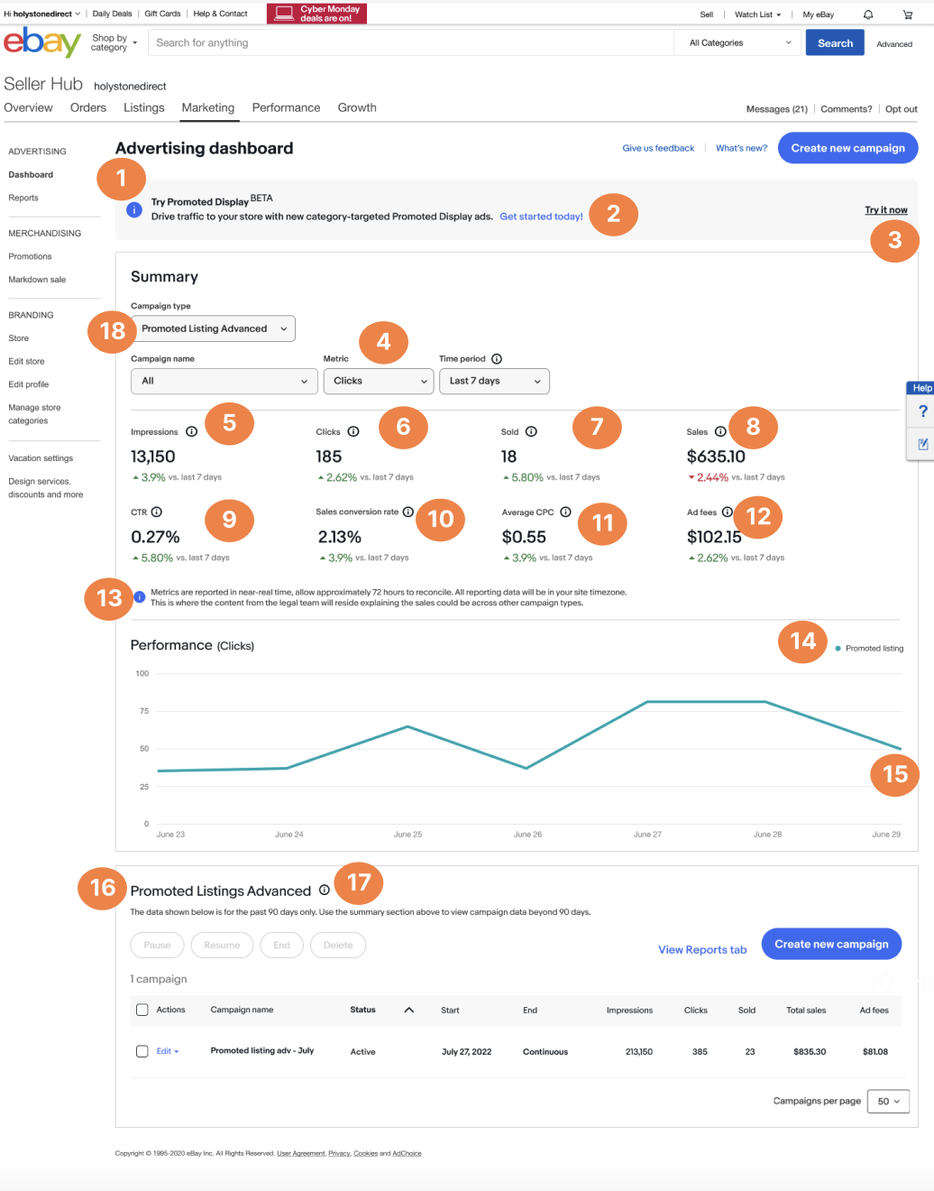

## Reporting Line Image

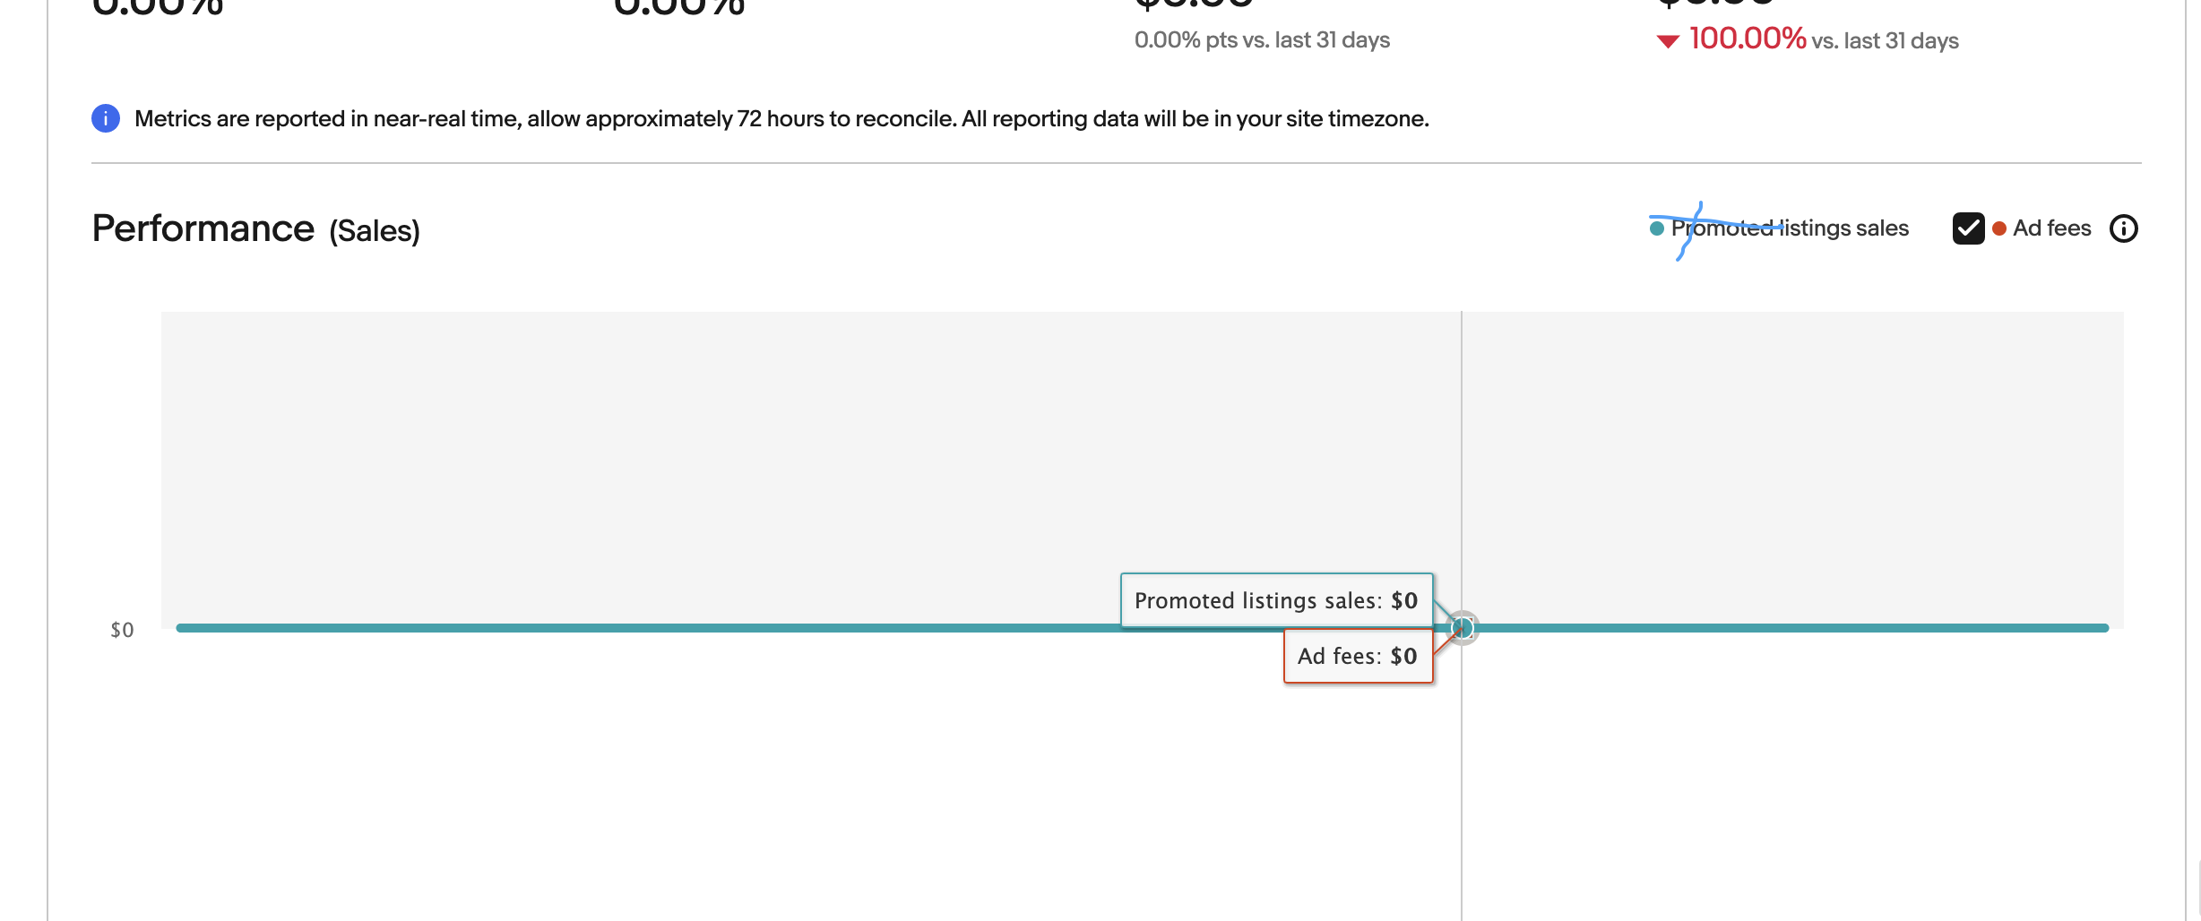

# ****Advertising Dashboard - Content**** Post Campaign Creation

|  |  |  |  |  |
| --- | --- | --- | --- | --- |
| **Position** | **#** | **Mock Content** | **Final Content** | **Notes/Use Cases** |
| Success Banner | 1 | **Congratulations. You’ve successfully launched**: <Summer Promoted Display campaign: June 2022>. Your ads will appear on eBay within a few hours and will run during the dates you selected, unless you pause or end your campaign.  Need to make a change? Edit campaign Checkout the latest ways to improve your store for buyers. Edit store | **Congratulations! You've successfully launched [Campaign name].** Your ads will appear on eBay during the dates you've set unless you pause or end your campaign. | Edit campaign &  Edit store are links. |
| Reporting Link | 2 | View Reports tab | View Reports tab |  |
| Button | 3 | Create Promoted Display Campaign | Create Promoted Display Campaign |  |
| ~~Metric~~ | ~~4~~ | ~~ROAS~~ | ~~ROAS~~ | ~~"ROAS" needs to be added next to "Ad fees" metric~~  no longer needed as of 8/17 |
| Dropdown carrot | 5 | <dropdown carrot next to edit button> | <dropdown carrot next to edit button>  This link will be a drop down to "download category report", "pause" and "end" | See Edit Drop Down Image  This link will be a drop down to "download category report", "pause" and "end" |

# ****Advertising Dashboard - Image**** Post Campaign Creation

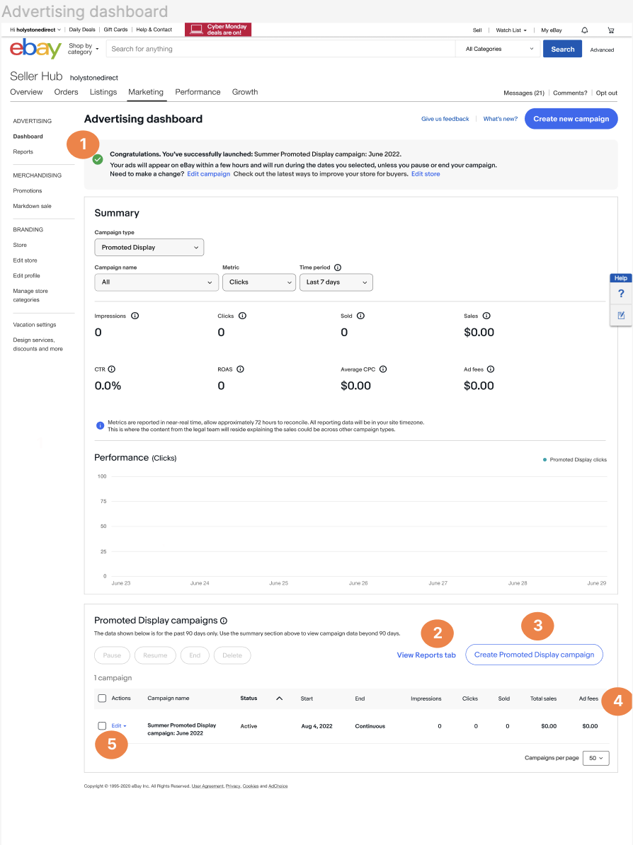

## ****Edit drop down Image****

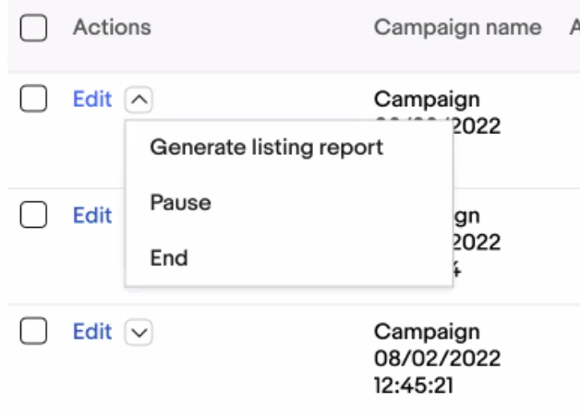

# ****Advertising Dashboard - Content****Confirmation Messaging

|  |  |  |  |  |
| --- | --- | --- | --- | --- |
| **Position** | **#** | **Mock Content** | **Final Content** | **Notes/Use Cases** |
| Success Banner | 1 | Success! Summer Promoted Display campaign: June 2022 has been edited. See reporting details below. | Congratulations! You've successfully edited [Campaign name]. Your ads will appear on eBay during the dates you've set unless you pause or end your campaign. |  |

# ****Advertising Dashboard - Image**** Confirmation Messaging

